Mission/Office/Team/Unit:  USAID/XYZ - ABC TEAM | Date:  Date | Facilitators:  Jane Doe (Facilitator); John Doe (Note-Taker)

Topic Selection
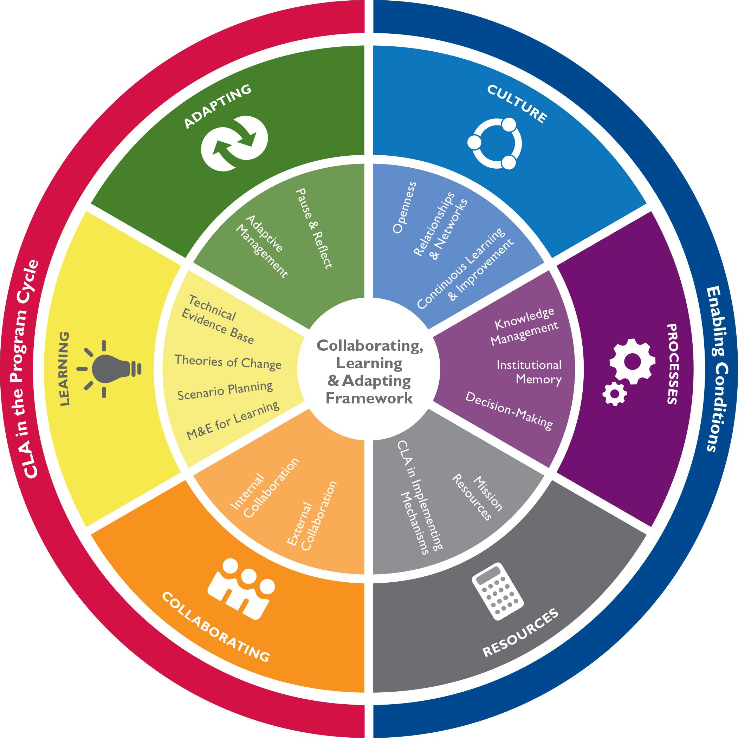
[X number] members of USAID/[Mission Name] [Team Name] used the CLA Framework and CLA Maturity Tool to discuss what CLA looks like in practice, at various levels of maturity, in their work together.

For each of the subcomponent topics in the CLA Framework, the tool describes a spectrum of maturity, from ‘Not Yet Present’ to ‘Institutionalized,’ with each stage described on a card. Working through the cards catalyzed conversations about how the [office/team] is currently incorporating CLA into its work, and how they can strengthen these efforts in the areas they prioritized.

The participants chose to discuss the following subcomponents: [List them here]. They also expressed interest in [add any additional topics], but there was not sufficient time to cover the additional topics.

Based on their self-assessment conversation, they generated a number of ideas about how they could incorporate CLA approaches related to [list the topics] into their work more systematically. They selected a few priority ideas for action planning, and developed a targeted and feasible approach to help guide the [office/team’s] work over the next [action planning timeframe].

[Any additional information, such as plans to involve others, to continue discussing the additional topics of interest identified, or finalize and socialize the action plan.]

[Mission/OU/Org] can also find tools, resources, and examples the CLA Toolkit.

Internal Collaboration - Self-Assessment Discussion Notes
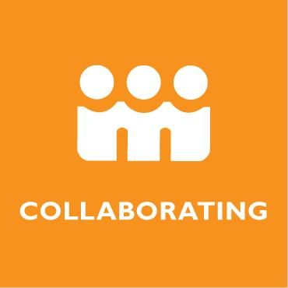 | NOT YET PRESENT | EMERGENT | EXPANDING | ADVANCED | INSTITUTIONALIZED
 | We are not yet collaborating with other teams/offices. | - We collaborate with other teams/offices in an ad hoc fashion.  - Information silos are common. | - We sometimes collaborate with other teams/offices.  - Inter-office collaboration is characterized by information exchange. | We usually:  - Identify other teams/offices and/or individuals who could have the greatest impact on planning and implementation.  - Make decisions about what form collaboration takes to increase synergies.  - Collaborate strategically with those teams/offices and/or individuals based on decisions reached. | We consistently and systematically:  - Identify other teams/offices and/or individuals who could have the greatest impact on planning and implementation.  - Make decisions about what form collaboration takes to increase synergies.  - Collaborate strategically with those teams/offices and/or individuals based on decisions reached.
Current State Votes: | XX XXXX
Aspirational State Votes | XX X XXX
- DISCUSSION NOTES GO HERE

External Collaboration - Self-Assessment Discussion Notes
 | NOT YET PRESENT | EMERGENT | EXPANDING | ADVANCED | INSTITUTIONALIZED
 | We are not yet collaborating with stakeholders. | - Analysis of stakeholders is informal and undocumented.  - Mission / team collaborates with external stakeholders in an ad hoc fashion.  - External stakeholders are informed of USAID plans and/or interventions. | - Planning processes sometimes include a stakeholder analysis.  - We collaborate with host government counterparts and/or implementing partners under specific agreements.  - Collaboration with additional stakeholders limited to consultation/information gathering to inform USAID decisions. | We usually:  - Use stakeholder analysis to identify and prioritize stakeholder.  - Make decisions about what form collaboration takes to increase synergies, which could include encouraging collaboration among partners when relevant.  - Collaborate strategically with key stakeholders based on comparative advantages. | We consistently and systematically:  - Use stakeholder analysis and engagement strategy is thorough and consistently revisited, particularly at key decision-making junctures.  - Make decisions about what form collaboration takes to increase synergies, which includes requiring and resourcing collaboration among partners when relevant.  - Collaborate strategically with key stakeholders consistently results in co-creation of initiatives, and joint implementation based on comparative advantages.
Current State Votes:
Aspirational State Votes
- DISCUSSION NOTES GO HERE

Technical Evidence Base - Self-Assessment Discussion Notes
 | NOT YET PRESENT | EMERGENT | EXPANDING | ADVANCED | INSTITUTIONALIZED
 | We are not familiar with the technical evidence base. | - We informally track the existing technical evidence base.  - We have identified some knowledge gaps. | - We primarily track and use previous evaluation reports to identify implications for programming.  - We fill knowledge gaps using informal or ad hoc approaches. | We usually:  - Track the existing technical evidence base, including up-to-date research and subject matter expertise generated by USAID & others.  - Use a mix of relevant knowledge types and sources to identify implications and inform strategy, projects, and/or activities.  - Fill gaps and contribute new knowledge to the evidence base through a mix of knowledge synthesis, research, piloting/ experimentation & evaluation. | We consistently and systematically:  - Track the existing technical evidence base, including up-to-date research and subject matter expertise generated by USAID & others.  - Use a mix of relevant knowledge types & sources to identify implications & inform strategy, projects & activities.  - Fill gaps and contribute new knowledge to the evidence base through a mix of knowledge synthesis, research, piloting/ experimentation & evaluation.
Current State Votes:
Aspirational State Votes
- DISCUSSION NOTES GO HERE

Theories of Change - Self-Assessment Discussion Notes
 | NOT YET PRESENT | EMERGENT | EXPANDING | ADVANCED | INSTITUTIONALIZED
 | We have not yet developed a theory of change. | - Theories of change typically describe activities already in place. | - Logical theories of change are developed based on an understanding of existing technical evidence, and assumptions are identified.  - Some aspects of theories of change are tested through evaluations.  - Theories of change are shared and understood among a limited number of staff and key stakeholders. | - Logical theories of change are developed based on an understanding of the context and relevant analyses, as well as existing technical evidence.  - We regularly test and explore prioritized theories and their assumptions using a variety of learning approaches beyond evaluations.  - Theories of change are widely shared and understood by the majority of staff and key stakeholders. | We systematically:  - Develop logical theories of change with sufficient stakeholder input and based on an understanding of the context, relevant analyses, and existing technical evidence.  - Test and explore theories of change and their assumptions and modify theories (as needed) based on results.  - Use and share learning from testing theories of change to inform USAID's and other stakeholders' planning and implementation.
Current State Votes:
Aspirational State Votes
- DISCUSSION NOTES GO HERE

Scenario Planning - Self-Assessment Discussion Notes
 | NOT YET PRESENT | EMERGENT | EXPANDING | ADVANCED | INSTITUTIONALIZED
 | We have not yet participated in scenario planning. | - We informally ask big picture ‘what if?” questions. | - We ask and document big picture “What if?” questions.  - We informally monitor trends related to those questions. | - We usually develop scenario narratives to reflect on potential risks and opportunities.  - We regularly monitor trends related to those scenarios.  - Monitoring of scenarios often informs planning and implementation. | - We consistently develop scenario narratives, identifying early warning signals for anticipated risks or opportunities.  - We systematically monitor trends related to scenarios.  - We use early warning signals to respond to context changes in real-time.
Current State Votes:
Aspirational State Votes
- DISCUSSION NOTES GO HERE

M&E for Learning - Self-Assessment Discussion Notes
 | NOT YET PRESENT | EMERGENT | EXPANDING | ADVANCED | INSTITUTIONALIZED
 | M&E efforts are implemented primarily for meeting reporting requirements. | - Monitoring data is generally disconnected from decision-making.  - Required evaluations identify new and relevant information. | - Monitoring data is sometimes relevant and of sufficient rigor to inform decision-making.  - We use evaluation findings to inform future activities or projects.  - We align learning across multiple activities to inform future activity or project design. | We usually identify and collect good-quality, credible monitoring data that informs decision-making.  - We regularly design and conduct evaluations to inform ongoing and future programming.  - We intentionally design M&E efforts so resulting learning can be aggregated across projects and/or activities to inform design and implementation decisions. | - We consistently prioritize and collect high-quality, credible monitoring data that informs decision-making.  - We design and conduct timely evaluations that inform ongoing and future programming.  - We intentionally design M&E efforts so resulting learning can be aggregated across projects and/or activities, and feeds up to inform achievement of mission-level results.
Current State Votes:
Aspirational State Votes
- DISCUSSION NOTES GO HERE

Pause & Reflect - Self-Assessment Discussion Notes
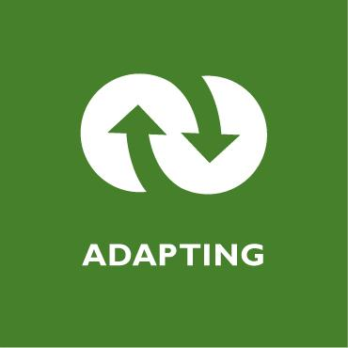 | NOT YET PRESENT | EMERGENT | EXPANDING | ADVANCED | INSTITUTIONALIZED
 | We have not yet participated in pause & reflect opportunities. | - We participate in required annual portfolio reviews and CDCS mid-course stocktaking for accountability and reporting purposes.  - Partner meetings are rare and are used to provide information to implementing partners.  - Additional pause & reflect opportunities might be identified, but are not acted upon. | - We participate in portfolio reviews and ad hoc partner meetings focused primarily on activity-level learning, as well as CDCS mid-course stocktaking.  - Pause & reflect (P&R) activities are not aligned to design and implementation schedules.  - P&R activities are characterized by information dissemination and basic knowledge exchange. | We usually:  - Host and attend a variety of relevant pause & reflect (P&R) activities to reflect on progress and learning to date.  - Hold P&R activities to feed into design and implementation schedules so learning is generated when most usable.  - Facilitate P&R activities for staff and relevant stakeholders, using a variety of participatory approaches to encourage candid conversation. | We consistently and systematically:  - Host and attend a variety of relevant pause & reflect (P&R) activities to reflect on progress and learning to date.  - Hold P&R activities to feed into design and implementation schedules so learning is generated when most usable.  - Facilitate P&R activities for staff and relevant stakeholders, using a variety of participatory approaches to encourage candid conversation.
Current State:
Aspirational State:
- DISCUSSION NOTES GO HERE

Adaptive Management - Self-Assessment Discussion Notes
 | NOT YET PRESENT | EMERGENT | EXPANDING | ADVANCED | INSTITUTIONALIZED
 | We have not yet identified opportunities to apply learning or course correction. | We work with partners to identify successes, challenges, and subjects that warrant further exploration at the activity level. | We work with partners to:  - Identify successes, challenges, and subjects that warrant further exploration at the activity level.  - Use learning to inform activity-level decisions on maintaining or adapting current approaches.  - Sometimes take action based on decisions reached, consulting with key colleagues in the mission as needed. | We usually:  - Work with key internal and external stakeholders to analyze successes, challenges & failures to identify lessons and subjects that warrant further exploration.  - Use learning to inform decisions on maintaining, adapting, or discontinuing current approaches.  - Work with key colleagues in the mission and Washington bureaus (as appropriate) to take action to adapt strategy, projects, and/or activities accordingly. | We consistently and systematically:  - Work with key internal and external stakeholders to analyze successes, challenges & failures to identify lessons and subjects that warrant further exploration.  - Use learning to inform decisions on maintaining, adapting, or discontinuing current approaches.  - Work with key colleagues in the mission and Washington bureaus (as appropriate) to take action to adapt strategy, projects, and/or activities accordingly.
Current State:
Aspirational State:
- DISCUSSION NOTES GO HERE

Openness - Self-Assessment Discussion Notes
 | NOT YET PRESENT | EMERGENT | EXPANDING | ADVANCED | INSTITUTIONALIZED
 | Openness to sharing and hearing alternative perspectives or trying novel approaches in not yet part of mission culture. | Only certain individuals:  - Ask difficult questions or feel able to express unpopular viewpoints.  - Invite alternative perspectives.  - Are willing to explore untested or novel ideas. | A minority of mission staff:  - Ask difficult questions or feel able to express unpopular viewpoints.  - Invite alternative perspectives.  - Are willing to explore untested or novel ideas. | The majority of mission staff:  - Ask difficult questions or feel able to express unpopular viewpoints.  - Invite alternative perspectives.  - Are willing to explore untested or novel ideas. | Staff mission-wide, with the support of mission leadership, consistently:  - Ask difficult questions or feel able to express unpopular viewpoints.  - Invite alternative perspectives.  - Are willing to explore untested or novel ideas.
Current State:
Aspirational State:
- DISCUSSION NOTES GO HERE

Relationships & Networks - Self-Assessment Discussion Notes
 | NOT YET PRESENT | EMERGENT | EXPANDING | ADVANCED | INSTITUTIONALIZED
 | Staff are not yet leveraging relationships and networks. | Only certain individuals:  - Have strong internal & external relationships & networks based on mutual trust.  - Consistently & transparently communicate w/a wide range of stakeholders to exchange up-to-date information and tacit knowledge.  - Use relationships & networks to remain aware of developments across the system that could impact, leverage, or streamline ongoing or future efforts. | A minority of mission staff:  - Have strong internal & external relationships & networks based on mutual trust.  - Consistently & transparently communicate w/a wide range of stakeholders to exchange up-to-date information and tacit knowledge.  - Use relationships & networks to remain aware of developments across the system that could impact, leverage, or streamline ongoing or future efforts. | The majority of mission staff:  - Have strong internal & external relationships & networks based on mutual trust.  - Consistently & transparently communicate w/a wide range of stakeholders to exchange up-to-date information and tacit knowledge.  - Use relationships & networks to remain aware of developments across the system that could impact, leverage, or streamline ongoing or future efforts. | Staff mission-wide:  - Have strong internal & external relationships & networks based on mutual trust.  - Consistently & transparently communicate w/a wide range of stakeholders to exchange up-to-date information and tacit knowledge.  - Use relationships & networks to remain aware of developments across the system that could impact, leverage, or streamline ongoing or future efforts.
Current State:
Aspirational State:
- DISCUSSION NOTES GO HERE

Continuous Learning & Improvement - Self-Assessment Discussion Notes
 | NOT YET PRESENT | EMERGENT | EXPANDING | ADVANCED | INSTITUTIONALIZED
 | Staff are able to focus on learning and reflecting only outside of regular working hours. | Only certain individuals:  - Make time for their own learning and reflection.  - Use iterative approaches that enable continuous improvement. | A minority of mission staff:  - Participate in learning and reflection opportunities.  - Use iterative approaches that enable continuous improvement. | - A majority of mission staff participate in learning and reflection opportunities.  - Staff are usually motivated to learn in order to grow professionally and improve organizational effectiveness.  - A majority of staff and implementing partners use iterative approaches that enable continuous improvement. | - Staff mission-wide, with the support of mission leadership, participate in learning opportunities and capture how they contribute to the organization's effectiveness.  - Staff are consistently motivated to learn in order to grow professionally and improve organizational effectiveness.  - Mission leadership consistently encourages staff and implementing partners to use iterative approaches that enable continuous improvement.
Current State:
Aspirational State:
- DISCUSSION NOTES GO HERE

Knowledge Management - Self-Assessment Discussion Notes
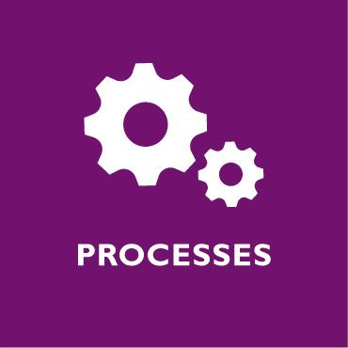 | NOT YET PRESENT | EMERGENT | EXPANDING | ADVANCED | INSTITUTIONALIZED
 | We are not yet sourcing, distilling, and/or sharing knowledge. | In planning and implementation, we rarely:  - Source relevant technical, contextual, and experiential knowledge from key stakeholders.  - Distill knowledge to inform decisions.  - Share knowledge strategically and in in user-friendly formats to influence decisions within and outside USAID. | In planning and implementation, we sometimes:  - Source relevant technical, contextual, and experiential knowledge from key stakeholders.  - Distill knowledge to inform decisions.  - Share knowledge strategically and in in user-friendly formats to influence decisions within and outside USAID. | In planning and implementation, we usually:  - Source relevant technical, contextual, and experiential knowledge from key stakeholders.  - Distill knowledge to inform decisions.  - Share knowledge strategically and in in user-friendly formats to influence decisions within and outside USAID. | In planning and implementation, we consistently and systematically:  - Source relevant technical, contextual, and experiential knowledge from key stakeholders.  - Distill knowledge to inform decisions.  - Share knowledge strategically and in in user-friendly formats to influence decisions within and outside USAID.
Current State:
Aspirational State:
- DISCUSSION NOTES GO HERE

Institutional Memory - Self-Assessment Discussion Notes
 | NOT YET PRESENT | EMERGENT | EXPANDING | ADVANCED | INSTITUTIONALIZED
 | We do not yet have systems or processes in place to maintain institutional memory. | - We have knowledge management system(s) that are not in use.  - Transition and onboarding processes are articulated, but not implemented. | - Mission staff use a knowledge management system for daily operational needs and basic access to institutional knowledge.  - Ad hoc knowledge transfer between incoming and outgoing staff depends largely on individual initiative.  - Foreign service nationals sometimes play a role in maintaining knowledge continuity. | - Mission staff and relevant stakeholders are able to access needed information and knowledge.  - Departing and/or current staff usually transfer mission knowledge, understanding of the local context, and key relationships to incoming staff.  - Foreign service nationals are usually valued as a source of institutional knowledge and encouraged to contribute to staff onboarding and transition processes. | - Mission staff and relevant stakeholders are able to easily access up-to-date information and knowledge in a timely manner.  - Departing and/or current staff systematically transfer mission knowledge, understanding of the local context, and key relationships to incoming staff.  - Foreign service nationals are consistently valued as a source of institutional knowledge and are encouraged to contribute to staff onboarding and transition processes.
Current State:
Aspirational State:
- DISCUSSION NOTES GO HERE

Decision-Making - Self-Assessment Discussion Notes
 | NOT YET PRESENT | EMERGENT | EXPANDING | ADVANCED | INSTITUTIONALIZED
 | We do not yet have clarity around decision-making processes or authority. | - Only certain mission staff and implementing partners understand programmatic decision-making processes or the scope of their own autonomy.  - Rationale for decisions taken is rarely documented and only shared with stakeholders after the fact. | - A minority of mission staff and implementing partners understand decision-making processes at the mission.  - The level of autonomy staff have to make decisions about their work differs according to the teams and individuals involved.  - Decisions are sometimes made after soliciting input from stakeholders and the rationale is documented and shared with them. | - The majority of mission staff and implementing partners understand decision-making processes.  - Staff are usually granted an appropriate level of autonomy to make decisions about their work.  - Decisions are usually made after soliciting input from appropriate internal and external stakeholders and the rationale is documented and shared with them. | - The process for making decisions is fully transparent.  - Staff are consistently granted an appropriate level of autonomy to make decisions about their work.  - Decisions are consistently made after soliciting input from appropriate internal and external stakeholders and the rationale is documented and shared with them.
Current State:
Aspirational State:
- DISCUSSION NOTES GO HERE

Mission Resources - Self-Assessment Discussion Notes
 | NOT YET PRESENT | EMERGENT | EXPANDING | ADVANCED | INSTITUTIONALIZED
 | We are not yet leveraging financial and human resources to support CLA integration throughout the Program Cycle. | - The mission’s M&E specialist(s) are responsible for CLA.  - Only a few individuals are trained in and recognized for CLA-related knowledge and skills. | - The mission’s M&E specialist(s) and points of contact from technical offices are responsible for CLA.  - A minority of staff are trained in and recognized for CLA-related knowledge and skills.  - The mission has support mechanism(s) with some elements relating to CLA. | - The mission has CLA points of contact in the Program Office and across the technical offices.  - A majority of staff are trained in and recognized for CLA-related knowledge and skills.  - The mission procures mechanisms to support CLA. | - Staff mission-wide incorporate CLA into their scope and workload, and there are identified CLA champions throughout the mission who coordinate efforts with the Program Office.  - Staff mission-wide are trained in and recognized for CLA-related knowledge and skills.  - The mission procures and uses tailored support to promote effective CLA.
Current State:
Aspirational State:
- DISCUSSION NOTES GO HERE

CLA in Implementing Mechanisms - Self-Assessment Discussion Notes
 | NOT YET PRESENT | EMERGENT | EXPANDING | ADVANCED | INSTITUTIONALIZED
 | Implementing mechanisms are not yet supporting CLA integration. | We rarely:  - Use mechanism types and scopes that enable CLA integration during implementation.  - Allocate and/or approve mechanism resources to support CLA integration.  - Request and/or approve key personnel with capacity in adaptive management and other CLA-related skills. | We sometimes:  - Use mechanism types and scopes that enable CLA integration during implementation.  - Allocate and/or approve mechanism resources to support CLA integration.  - Request and/or approve key personnel with capacity in adaptive management and other CLA-related skills. | We usually:  - Use mechanism types and scopes that enable CLA integration during implementation.  - Allocate and/or approve mechanism resources to support CLA integration.  - Request and/or approve key personnel with capacity in adaptive management and other CLA-related skills. | We consistently and systematically:  - Use mechanism types and scopes that enable CLA integration during implementation.  - Allocate and/or approve mechanism resources to support CLA integration.  - Request and/or approve key personnel with capacity in adaptive management and other CLA-related skills.
Current State:
Aspirational State:
- DISCUSSION NOTES GO HERE

CLA ACTION BRAINSTORMING AND PRIORITIZATION
Priority Action Ideas  Through a group brainstorming exercise, the [office/team] developed this list of ideas based on all [number] topics covered during the self-assessment session, some of which were similar and are clustered together in the table below. They then voted on these ideas to determine which should be explored further through the action planning process. Each participant got [number] votes. The detailed action plan is listed below this table. | Impact | Effort | Votes
- Add idea or cluster of ideas here | High  Med-High  Medium  Med-Low  Low | High  Med-High  Medium  Med-Low  Low

INITIAL PLANNING ON PRIORITY ACTIONS
Within X months/years
Action Item | Expected Outcome(s) | Next Steps | Timeline | Person Responsible | Resources | Connections to Current Work and/or Processes
[Chosen idea from brainstorming/prioritization]

