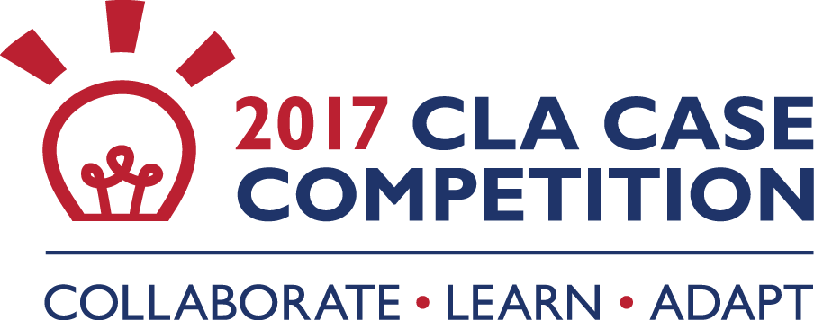

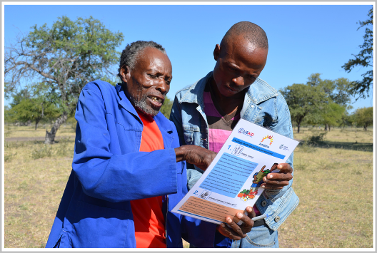
Case Title:

Stop, Reflect, Improve: Using CLA to Engage Men to Improve Women and Children's Health

Author: Melissa Antal, Mackson Maphosa, Mutsa Dzimba
Organization: The Manoff Group

Summary:
Frank Dube, male champion, coaches his neighbor on his role in ensuring his family is healthy and his children are growing well. Credit: Mackson Maphosa.

The Amalima project builds on existing communal initiatives to sustainably improve household food and nutrition security by strengthening access to and availability of food, community resilience to shocks, and nutrition and health among mothers and children in western Zimbabwe. One important project objective is to improve the nutrition practices of local mothers. Our formative research indicated that women did not practice optimal breastfeeding behavior for a variety of reasons, among them men’s attitudes towards it. The research also informed the development of our initial behavior change strategy and approach that reached female caregivers, with men as a secondary audience.

A mid-project survey showed that while some behaviors were improving, others were not—in part because their improvement required male partner endorsement and support. To establish impactful and realistic male involvement goals, we engaged both men and women in a consultative process that generated a list of realistic, supportive behaviors that could be promoted with men. The resultant Male Involvement Campaign leveraged respected local leaders to engage men to lead tailored outreach programs to discuss men’s roles and responsibilities in infant and young child feeding (IYCF). A subsequent case-control study found a statistically significant improvement in the key behaviors promoted by the campaign in the pilot area.

The project’s ongoing collaborating, learning, and adapting (CLA) approach enables the project team to assess and identify opportunities for improvement and ultimately will help ensure that the project has the right strategies in place to reach its IYCF objectives.

Which subcomponents of the Collaborating, Learning and Adapting Framework are reflected most in your case (select up to 5 subcomponents)?

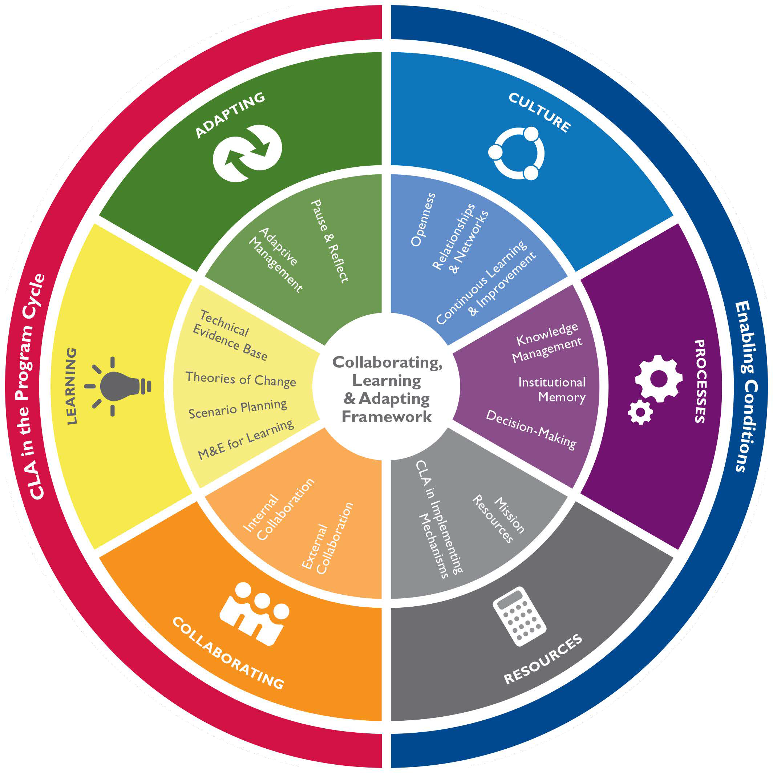
Pause & Reflect Adaptive Management Technical Evidence Base Theories of Change Scenario Planning
✔
✔
M&E for Learning Internal Collaboration External Collaboration
✔
Openness
Relationships & Networks
✔
Continuous Learning & Improvement
✔
Knowledge Management Institutional Memory Decision-Making Mission Resources
CLA in Implementing Mechanisms

What is the general context in which the case takes place?

The Amalima program draws its name from the Ndebele word for the social contract by which families come together to help each other engage in productive activities such as land cultivation, livestock tending, and asset buildings. The five-year, USAID Food for Peace Development Food Assistance Program, led by CNFA, builds on existing communal initiatives to sustainably improve household food and nutrition security by strengthening access to and availability of food, community resilience to shocks, and nutrition and health among mothers and children in western Zimbabwe.

In these patriarchal communities, men exercise significant influence over mothers' ability to feed children and the related choices mothers make as caregivers. Very little, if any, prior research into Zimbabwean men’s involvement with IYCF existed prior to our program’s launch, so we conducted formative research with caregivers which revealed the direct and indirect impact of men. The learnings from this research informed the development of a behavior change strategy and approach that reached caregivers—generally women—through care groups and home counseling visits. These activities were intended to include men as a secondary audience.

Two years into initial program implementation, activities were having a positive impact and uptake was improving for key promoted behaviors. For example, the percentage of mothers reporting that they were exclusively breastfeeding increased from 44.9% to 84.2% over a two-year period.

However, the same survey found that quality of individual breastfeeding sessions had not improved. As was found by the formative research, only half of mothers breastfed for at least 20 minutes, denying infants the nutritional and satiety benefits of the higher-fat hind milk available with longer feeding sessions. While our formative research showed that women knew the optimal amount of time to breastfeed at each session, that knowledge did not translate into behavior, even after our intervention. As found previously, the reason women shortened sessions was because men thought these mothers were being lazy instead of “productive” if they sat to breastfeed for the proper time.

Our assumption that men would be supportive, even if not directly targeted, was wrong. Review of program data confirmed that male participation in care group and home visit activities was low. Male participation had been identified as crucial to achieving impact, and the program needed to develop a better strategy to directly engage them.

Why did you use a collaborating, learning, and adapting approach?
We used a CLA approach because our original strategy for engaging men in activities was not on track to achieve the desired IYCF outcomes. The team could either carry on as planned, or stop to assess and identify opportunities for improvement.

-Collaborating: CLA enabled us to strengthen our external collaboration with program participants to improve the program. We did not know what behaviors we needed to encourage men to adopt to be more supportive to mothers. We worked first with women to identify specific practices for men, and then worked with men to respond to those suggested behaviors to arrive at those that would be promoted by the program.
-Learning: CLA allowed us to leverage monitoring and evaluation (M&E) to learn how best to involve men. While we knew a great deal about men in the communities where we worked, we did not know what women wanted them to do. This type of research was unprecedented. We needed to create a new, open space where we could understand what behaviors women wanted from men, which of those behaviors men were willing and able to do, and what would motivate them to be more supportive and engaged.
-Adapting: CLA created an opportunity for adaptive management, and for staff to work together to solve a common problem. Working with the entire team, we applied adaptive management strategies to translate new findings into a strategic response. The result was a male-focused campaign that boosted male support for improved nutrition practices, including the reduction of women’s workload.

Describe how you used collaborating, learning, and adapting in this case.
Step One: We realized the opportunity.
We were seeing good results in outcome indicators, but our data showed us that there was an opportunity to improve our approach and increase our impact by improving the quality of practiced behaviors. Pausing when there was positive momentum was a risk, and the team considered continuing without changes to our approach.
Management was open to proposed improvements, however, and supported us taking a calculated risk.

Step Two: We returned to the formative research results.
Our first reflection was to check what we had learned during our formative research. Our strength was integrating key findings into our program activities targeting women. We had also gained valuable information about men during our formative research, including reasons why they were not active supporters of exclusive breastfeeding, but these findings had not been translated into program activities.

Step Three: We recognized what we still did not know and conducted research to fill the gap.
The actions men should be encouraged to adopt to support improved nutrition practices were not immediately clear. To establish impactful and realistic male involvement goals, we engaged men and women through a consultative, participatory process. First, women-only focus groups were asked to define what practices they would like their husbands to adopt to support exclusive breastfeeding. Next, those practices were shared with participants in
men-only focus groups, and male participants decided on the feasibility and social acceptability of each. The result was a list of realistic, supportive behaviors that could be promoted with men.

Step Four:
We consolidated our learnings to build a Male Involvement Campaign. Our research found that men: respected village leadership, authority and their friends; would follow the actions of their peers; respected their wives and wanted to help them; felt pride in the health of their family; and wanted activities that were specially tailored to appeal to men. Building on these findings, we developed a strategy to increase male involvement centered on Male Champions (MCs).

How it works:
-MCs are invited by local leaders to assume the MC role and are trained by the project;
-Men commit to recruit at least 10 of their neighbors and friends to also participate;
-MCs organize monthly meetings to share a monthly lesson, discuss men’s roles and responsibilities in IYCF; and,
-MC groups train for soccer tournaments at group meetings to extend the purpose of meeting beyond lessons.

Step Five: We piloted with M&E to test and learn.
The strategy was piloted for six months, and 60 MCs were recruited. As of early 2017, almost 800 men had participated in peer meetings. Two soccer tournaments were organized, each attracting over 150 people, and offered the opportunity for MCs and community members to share and showcase their participation in Amalima activities. Couples shared testimonials about men’s roles in nutrition, and MCs presented plays, poems, and songs about male involvement in childcare and household chores, expanding the reach of the campaign to the wider community.

Step Six: We continue to track results and iterate our approach.
After the pilot concluded, the team held a workshop to examine what was planned, what actually occurred, what worked well, and what needed to be improved before expansion. We also conducted a case-control survey to identify differences in men’s behaviors in areas where the MC campaign was implemented in comparison to a control area. The survey found a statistically significant improvement in the key behaviors promoted by the campaign in the pilot area. As the team expands the approach within our project, we continue to test and adapt our campaign to include new topics such as village savings and loan (VSL) and income-generating activities.

5a. Organizational Impact: What impact, if any, has collaborating, learning, and adapting had on your team, mission or organization?
CLA has enabled the team to realize that each programmatic challenge can turn into a success if the right strategy and pathway are used.

Due to the success of the MC campaign and CLA approach that shaped the strategy, the team culture has shifted to be more open to identifying, testing and scaling up new ideas to tackle problems we face in achieving program impact. Following this success, an Amalima Learning Committee was established to formalize our commitment to a culture of leveraging M&E to learn, and continuing to engage with community members to strengthen the program.

Moving forward, CLA will allow us to continue to purposely solve program challenges with the community and adapt our strategy to local solutions. We continue to periodically engage the community to inform our programming. Within the expanded MC campaign, we are launching biannual meetings facilitated by the Ministry of Gender and traditional leaders to give MCs the opportunity to share feedback and identify new opportunities.

5b. Development Results: What impact, if any, has CLA had on your development outcomes?
- Men are practicing supportive behaviors.
Women in the MC campaign pilot area reported more supportive behaviors by their partners than women in the control area. Women scored their husbands or male head of household on 12 key behaviors promoted in the MC campaign. The average score in the MC pilot communities was 20.2 (out of 30). In the control communities, the average score was 15.4, a statistically significant difference (p value= 0.000). An unexpected outcome is men’s adoption of behaviors we promoted as ideal, evidenced by their participation in cooking classes. A comprehensive evaluation of the expansion is planned for 2017.

- Men are now more involved in Amalima.
Additionally, there has been an increase in the number of men involved in program activities once seen as "women only" activities. With more than 800 MCs and peers now involved in Amalima, we are confident that we made the right decision to apply CLA to improve male involvement.

- Male involvement improves women’s empowerment.
Our team is now working directly with men to promote behaviors that are helpful to women. By facilitating discussion with men first, we identified an opportunity to create dialogue and action between men and women. Our curriculum speaks to men from their perspective and builds from evidence of what is proven to incite behavior change. To further assess the impact of our MC campaign, a formal evaluation is underway.

What factors affected the success or otherwise of your collaborating, learning and adapting approach? What were the main enablers or barriers?
Calculated risk taking: It was a risk to admit that despite good initial results, we still needed to do better to improve the quality of the program. We could have continued with the program, but to maximize our impact, we could not ignore the fact that we had not done enough to involve men.
-Barriers: Staff time and effort was required to hit “pause” and step back to better understand why the quality of breastfeeding sessions and other nutrition behaviors could be improved.
-Enablers: Technical team flexibility and enthusiasm to try out a new idea and strategy. The team was committed to continuously improve our program and increase our own skills.

Valuing the voice of our program participants: We created a better campaign because we involved program participants. Had we worked independently, the team would have focused on improving supportive nutrition behaviors. Our research guided us to confidently promote behaviors that lead to equal responsibilities of men and women at the household level.
-Barriers: Admitting we didn’t learn all we needed to from our formative research. Time and resources were needed to conduct more field work.
-Enablers: Senior management was on board with the need to understand how to better engage men and to allocate funding to make course corrections in the program. Senior management’s willingness to make funding available gave importance to the efforts of the team.

Based on your experience and lessons learned, what advice would you share with colleagues about using a collaborating, learning, and adapting approach?
You are never done iterating.
Program design should always include a learning component and have a degree of flexibility to allow for adaptation based on learning outcomes. Using a CLA approach has significantly increased male support and involvement in IYCF. Evidence from the pilot endline assessment shows that an increased number of men are now engaging in IYCF-supportive behaviors due to their exposure to campaign activities. This campaign was not part of the original program design. The success can mainly be attributed to team decision-making, based on learning outcomes and adaptive management.

Collaborate with program participants.
Including program participants in the learning process was necessary to ensure that whatever changes we proposed would be both acceptable and increase the likelihood of enabling the adoption of the behaviors we needed to see for impact. Internal collaboration is also critical to ensure ownership and participation by every team member. Be proactive to create opportunities to talk to program participants, the colleagues that work on other project components and field staff, to assess what is working and not working.

Take initiative. Be innovative. Take a risk.
Our team did these things to build and implement a widespread MC campaign (across four districts!) in a patriarchal society. Program teams should also be flexible to be able to adapt strategies and activities accordingly.

The CLA Case Competition is managed by USAID LEARN, a Bureau for Policy, Planning and Learning (PPL) mechanism implemented by Dexis Consulting Group and its partner, International Resources Group, a subsidiary of RTI.

